**Week 3: Learning Team A**

Marketing 571

University of Phoenix

November 14, 2016

# Enerzen Energy Product Launch

In a market saturated with sports drinks, Enerzen Energy stands alone. In outlining a product launch, it is important to understand the points of distinction between a product being launched and its competitors. Develop an understanding of the product and a plan to captivate the target market.

# The Offered Product Definition

The "dollar sales of energy drink beverages and shots in the United States in 2015 was 13.5 billion dollars" (Statista, 2016). An energy drink is a product marketed as a beverage or shot that provides the consumer with an energy boost to combat fatigue or replenish from a workout. As a rule, they are high in caffeine, frequently contain B vitamins, and other energy boosting ingredients. There are three subcategories in the energy drink market; drinks, shots (more concentrated), and powders.

# Assess the market needs for this product or service

Some might think that the world is already saturated with too energy drinks, however those same people are not looking at the larger picture. With the growing demand for healthy living, an alternative to sugary beverages and sodas is needed. Enerzen can fill that void as the transition unfolds.

The beverage industry is enormous with customers spending billions annually across the US alone. If Enerzen can capture a small amount of that market it can lead to huge profits for the company. Customers are also in need of more choices so that they can find the right healthy beverage for the situation.

# Choose an anticipated target audience and include a description.

The target audience would be people that want to live a healthy life, and are actively involved in sports. This would suggest that the psychographic audience would be members of gyms or related actives.

From this audience the ideal subset would have disposable income so that they can purchase multiple units with a certain regularity. It would also be acceptable to get the drink listed as health beverage instead of energy drink, this way food stamps can be used to purchase it. This has helped Monster compete against Red bull in the lower income markets.

# Defend your choice of product or service.

# Develop a brief SWOT analysis.

Strengths: Core Competencies

* Product development and innovation
* JIT manufacturing
* Strong vertical marketing relationships
* Differentiation
* Very strong team cohesiveness

Weakness:

* Lack of resources
* Time constraint
* Undercapitalized
* Hollow Structure (Everything is outsourced)
* Lack of experience

Opportunities:

* CVE certification
* By increasing product depth and breadth, we are able to meet specific consumer preferences and trends.
* DOD contracts/ marketing channel
* With CSD sales at a current decline, Beverage industry power players look to functional beverages for sustainable growth.

Threats:

* Industry leaders have placed barriers that are difficult to circumvent around.
* Market share leaders dictate the industry by pricing and offering promotional incentives (slotting fees, cooperative ads, strategic relationships bias) to retailers that for a small company, is impossible to meet.
* Large companies could mimic our product exactly, and be able to enter the market a lot faster as they have the means to do so due to the extent of their resources that could have serious negative implications for our product in the process.

(Trends:)

* Being more health conscious and lifestyle cognizant.
* Negative stigma towards energy drinks due to its unhealthy and even dangerous perceptions.
* Growing populations and better standards in living in emerging markets will drive demands for beverages particularly RTD’s (ready to drink teas), bottled water, and low calorie products due to rising health awareness across the globe.

# Potential Competition

Some of the bigger competitors currently in the market as it relates to drinks that provide energy include RedBull, Monster, Rockstar and NO5 ("Caffeine Informer", 2016). Their price comparison range from 1.10 to 2.85 per unit. Some of the hydration/sports drink leaders in the market include, Gatorade, Powerade, ONE and Vitamin Water ("Caffeine Informer", 2016).

# Potential Growth Rate

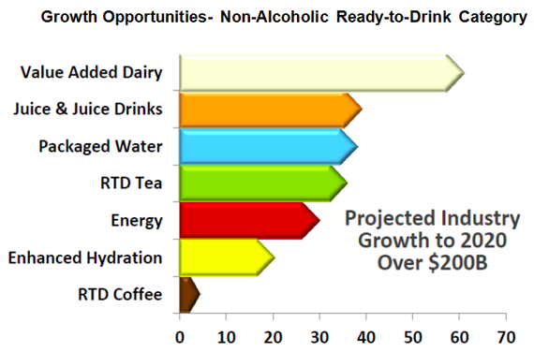

Key area of interest is the enhanced hydration and energy segment. Further industry analysis growth estimate by 2019, indicates that both segments combined will comprise of approximately 25% of industry growth, which conceptually illustrates Enerzen Energy’s overall long-term niche market potential.

# 10-Question Survey

Creating a survey and exploring buyer’s opinions and thought in regards to our product is instrumental in the continuous progress of the launching and maintaining a successful product. The following questions may be asked to gain better understanding of our product.

1- Do you spend time outdoors? If so, what is your preferred drink?

2- When I mention sports/energy drinks, what is the BRAND NAME that FIRST comes to mind? And why?

3- How often do you purchase sports/energy drinks?

4- For what activities would you use a sports/energy drink for? (Name all that apply)

5- Rank the factors that affect your choice of energy drinks.

(1-being the FIRST FACTOR CONSIDERED, 9-being the LAST)

a. Taste

b. Price

c. Packaging

d. Brand Name

e. Convenience

f. Effectiveness

g. Promotions (TV ads, print ads)

h. Availability in Major Stores

i. Company Affiliation

6- Why do you drink energy drinks?

7- What do you spend per day on them?

8- Where do you purchase them?

9- How many days per week do you drink them?

10- What makes you try a new energy drink? (more than one option is available)

a. Brand

b. Price

c. Packaging

d. Recommendations of friends

e. Advertising

f. Celebrities

# Why is it being conducted?

The goal of this survey is to gain more knowledge about the market we are trying to pursue and find out the demand in such market.

# How will the team benefit from the results in terms of planning and decision making?

# Conclusion

The Enerzen Energy drink brand is riding the edge of technology. Enerzen was designed by former service members who served in Iraq and Afghanistan. These veterans have designed a drink that provides the energy boost without the jitters and crash that are so common in the energy drink market. This drink also addresses the need for hydration, is naturally low calorie, and possesses "a tranquility factor that contains vital nutrients to help alleviate stress, anxiety, and improve overall well-being" (Enerzen Energy, 2016).

Caffeine Informer. (2016). Retrieved from http://www.caffeineinformer.com/the-15-top-energy-drink-brands